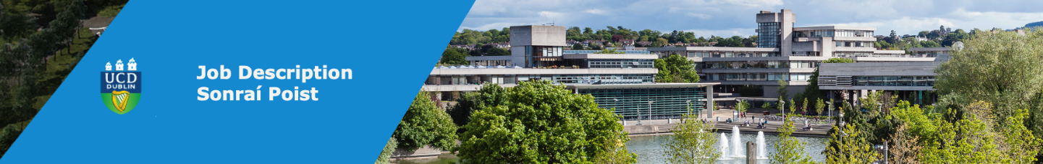

Instructions: Please complete in soft copy. Note, all sections are mandatory - unless specified otherwise.
Further instruction on completing this from is specified in the body of the form in this font.
College | Management Unit: | College of Engineering and Architecture
School | Unit: | School of Architecture, Planning and Environmental Policy
Post Title & Subject Area (if relevant) | PhD candidate (WP2. Laboratory Testing of Traditional Wall Materials / WP3. In-situ Testing of Pre & Post Retrofitted Traditional Walls)
Project: | Retrofit of TradFabs
Post Duration: | 3 year PhD position (full time)
Line Manager | Oliver Kinnane
Competition Ref. N⁰ | Completed by HR
HR Administrator | Completed by HR
Relocation Expenses | n/a
Garda Vetting | n/a

Position Summary:
Please describe the nature and purpose of the post (approx 100 – 150 words)

Applications are invited for a PhD candidate on the Retrofit of TradFabs project, for Work Packages WP2. Laboratory Testing of Traditional Wall Materials and WP3. In-situ Testing of Pre & Post Retrofitted Traditional Walls.

Project:
The objective of the Retrofit of TradFabs project (funded by the Sustainable Energy Authority of Ireland) is to provide knowledge and increased certainty around the hygrothermal performance and the appropriate thermal upgrading of solid masonry walls and traditional windows and doors, through laboratory and in-situ testing of such traditional assemblies pre and post retrofit, as well as their hygrothermal modelling.

Position:
The successful applicant will work under the direction of the Principal Investigator and the project team and will
- WP2: assist in the development and carrying out of hygrothermal laboratory testing of mortar / masonry composites with and without applied insulation as part of the project, adhering to established international standards, adjusted as appropriate to be applicable to the nature of the tested samples. The hygrothermal performance of representative masonry assemblies under controlled climatic conditions (hot box design incl. artificial weathering) is to be tested.
- WP3: assist in the set-up, development and carrying out of in-situ heatflux and moisture monitoring of pre/post retrofit case study wall assembly.
Academic fees for 3 years are covered by the project, as well as a PhD stipend (25,000€) for the full 3 year duration of the position.

Principal Duties and Responsibilities:
- Contribute to the detailed development of the required testing regimes
- Contribute to sample preparation and carrying out of hygrothermal testing
- Contribute to data analysis, collation and comparison of results
- Contribute to the publication of scientific papers
- Adhere to project timelines and administrative requirements

Particular to this position:
- Requirement to be available to undertake laboratory testing in the laboratory at UCD Newstead, and carry out test-setup and attendance of in-situ thermal and hygric monitoring of historic walls in different locations in Ireland

Salary: € - € Completed by HR

Appointment on the above range will be dependent on qualifications and experience

Details on eligibility to compete and pension information is available at
https://www.ucd.ie/hr/resourcing/eligibilitytocompete/

UCD welcomes applications from everyone. We are committed to creating an environment where diversity is celebrated and everyone is afforded equality of opportunity. Learn more about Diversity at
https://www.ucd.ie/workatucd/diversity/

Selection Criteria
Selection criteria outline the qualifications, skills, knowledge and/or experience that the successful candidate would need to demonstrate for successful discharge of the responsibilities of the post. Applications will be assessed on the basis of how well candidates satisfy these criteria.
Mandatory:

- Postgraduate qualification in a field of discipline relevant to the area of investigation (Architecture, material sciences, civil engineering or similar, MSc or equivalent)
- Good data analytical and computer skills
- Proficiency in MS Excel for data analysis
- Basic understanding of building physics
- Ability to work accurately in designing, implementing and writing up research independently
- Ability to work independently and take the initiative to implement outlined tasks
- Report to the team and PI on a regular basis
- Candidates must demonstrate an awareness of equality, diversity and inclusion agenda
Desirable:

- Previous research experience
- Previous experience with laboratory-based material testing (hygrothermal)
- Clear understanding of conservation principles of traditional buildings and the impact of moisture on solid masonry assemblies

Supplementary information:
Unless otherwise specified, URLs to the relevant home page(s) will be inserted by HR.

The University: | https://www.ucd.ie/
UCD Strategy 2020-2024: Rising to the Future | https://strategy.ucd.ie/

The College/Management Unit:
The School/Programme Office/Unit:
Equality Diversity and Inclusion at UCD | https://www.ucd.ie/workatucd/diversity/
Other (Please specify): | https://www.seai.ie/grants/research-funding/research-development-and-demonstration-fund/

Informal Enquiries ONLY to:

Please note this section is optional. Applications will be addressed to an assigned HR administrator.
Name: | Anna Hofheinz

Title:
Email address: | anna.hofheinz@ucd.ie

Telephone:

